Project Design Phase
Application Module Design and API Reference (Supplementary)
Date | 28 October 2026
Team ID | To Be Confirmed
Project Name | HotelPro – Hotel Management System
Maximum Marks | Supplementary
Document Status | Draft v1.0 – prepared from the stated HotelPro requirements. No HotelPro source code has been provided or verified, so all features are marked Planned.

1. Introduction
This document details the HotelPro application modules for Guest, Hotel Staff, Hotel Management and Admin users, together with the proposed REST API. Every module and endpoint is Planned; names are design proposals and must be reconciled with the source code (To Be Confirmed).

2. Module Catalogue

2.1 Guest Modules
Module | Planned Features | Key Endpoints | UI Pages | Requirement | Status
Registration, Login, Profile | Register with email verification; login with JWT; edit profile; change/reset password | POST /api/auth/register, /login; GET /api/auth/me; PUT /api/guests/me | Register, Login, Profile | FR-G1–G3, FR-X3 | Planned
Room Browsing and Search | List rooms with pagination; filter by dates, guests, type, price, amenities; room details with reviews | GET /api/rooms; GET /api/rooms/:id; GET /api/rooms/availability | Home, Room Listing, Room Details | FR-G4 | Planned
Room Booking and Reservations | Select dates and room; server-side price calculation; PENDING booking with hold; reference number | POST /api/bookings | Booking Form, Confirmation | FR-G5 | Planned
Online Payments | Create gateway order/intent; client checkout; server-side verification and webhook; invoice | POST /api/payments/create-order, /verify, /webhook | Payment Portal | FR-G6 | Planned
Booking History | List own bookings with filters; view details/invoice | GET /api/bookings/my; GET /api/bookings/:id | Guest Dashboard, Booking History | FR-G7 | Planned
Cancellation and Refund Requests | Cancel per policy; request modification; request refund | PATCH /api/bookings/:id/cancel; POST /api/payments/:id/refund-request | Booking History | FR-G8 | Planned
Reviews and Ratings | Rate completed stays; view own reviews | POST /api/reviews; GET /api/hotels/:id/reviews | Reviews and Feedback | FR-G9 | Planned
Notifications | In-app list, unread count, mark read; email notifications | GET /api/notifications; PATCH /api/notifications/:id/read | Notifications | FR-G10 | Planned

2.2 Hotel Staff Modules
Module | Planned Features | Key Endpoints | UI Pages | Requirement | Status
Check-In and Check-Out | Find booking; verify ID; record check-in/out; final bill | POST /api/stays/check-in, /check-out; GET /api/stays/arrivals, /departures | Staff Dashboard, Check-In/Out | FR-S1 | Planned
Room Status Updates | Change room status with transition rules | PATCH /api/rooms/:id/status | Room Status Board | FR-S2 | Planned
Reservation Management | Search/view reservations; create walk-in booking | GET /api/bookings; POST /api/bookings | Reservations | FR-S3 | Planned
Housekeeping | View and complete tasks; completion updates room status | GET /api/housekeeping/tasks; PATCH /api/housekeeping/tasks/:id | Housekeeping | FR-S4 | Planned
Service Requests | View, accept, complete guest requests | GET/PATCH /api/service-requests | Service Requests | FR-S5 | Planned
Customer Support | Reply to guest tickets | GET /api/support-tickets; POST /api/support-tickets/:id/reply | Support Desk | FR-S6 | Planned

2.3 Hotel Management Modules (manager sub-role)
Module | Planned Features | Key Endpoints | UI Pages | Requirement | Status
Room Inventory and Pricing | Create/edit rooms, categories, base prices, images | POST/PUT /api/rooms, /api/room-categories | Inventory | FR-M1 | Planned
Seasonal Pricing | Date-range pricing rules with priority | CRUD /api/pricing-rules | Pricing Rules | FR-M2 | Planned
Availability Tracking | Calendar view; block rooms for maintenance | GET /api/rooms/availability; PATCH /api/rooms/:id/status | Availability Calendar | FR-M3 | Planned
Booking Modifications and Approvals | Approve/reject change requests and exceptions | PATCH /api/bookings/:id/modification | Approvals | FR-M4 | Planned
Staff Assignment | Assign staff to tasks/requests | PATCH /api/staff/:id/assign; POST /api/housekeeping/tasks | Staff Assignment | FR-M5 | Planned
Occupancy Monitoring | Occupancy rate, room-status distribution, arrivals/departures | GET /api/manager/occupancy | Occupancy Dashboard | FR-M6 | Planned

2.4 Admin Modules
Module | Planned Features | Key Endpoints | UI Pages | Requirement | Status
User, Hotel and Staff Management | CRUD and activate/deactivate users, staff, hotels; role changes | GET/PATCH /api/admin/users; CRUD /api/hotels, /api/staff | Admin Dashboard, Users | FR-A1 | Planned
Booking Monitoring | Filter all bookings by hotel/status/date | GET /api/bookings (admin scope) | Bookings Monitor | FR-A2 | Planned
Payment Tracking | List payments, failures, refunds | GET /api/payments; PATCH /api/payments/:id/refund | Payments | FR-A3 | Planned
Reports and Analytics | Booking, occupancy, revenue reports; charts; export | GET /api/admin/reports/:type | Reports and Analytics | FR-A4 | Planned
Security Monitoring | Activity/security logs and filters | GET /api/admin/logs | Security Logs | FR-A5 | Planned
Platform Configuration | Cancellation policy, tax, notification settings | GET/PUT /api/admin/settings | Settings | FR-A6 | Planned

3. Proposed API Reference
Table 1: Proposed REST endpoints
Method | Endpoint | Access | Description | Status
POST | /api/auth/register | Public | Register a guest | Planned
GET | /api/auth/verify-email/:token | Public | Verify email | Planned
POST | /api/auth/login | Public | Login, returns JWT | Planned
POST | /api/auth/forgot-password | Public | Request reset link | Planned
POST | /api/auth/reset-password/:token | Public | Set new password | Planned
GET | /api/auth/me | Any authenticated | Current user | Planned
GET | /api/rooms | Public | List/search rooms (filters, pagination) | Planned
GET | /api/rooms/:id | Public | Room details | Planned
GET | /api/rooms/availability | Public | Available rooms for dates | Planned
POST | /api/rooms | Manager, Admin | Create room | Planned
PUT | /api/rooms/:id | Manager, Admin | Update room | Planned
PATCH | /api/rooms/:id/status | Staff, Manager, Admin | Update room status | Planned
GET/POST/PUT | /api/room-categories | Public read; Manager/Admin write | Manage categories | Planned
GET/POST/PUT/DELETE | /api/pricing-rules | Manager, Admin | Manage seasonal pricing | Planned
GET/POST/PUT | /api/hotels | Public read; Admin write | Manage hotels | Planned
POST | /api/bookings | Guest, Staff | Create booking (PENDING) | Planned
GET | /api/bookings/my | Guest | Own bookings | Planned
GET | /api/bookings | Staff, Manager, Admin | Search all bookings | Planned
GET | /api/bookings/:id | Owner, Staff, Admin | Booking details | Planned
PATCH | /api/bookings/:id/cancel | Owner, Staff, Admin | Cancel booking | Planned
POST | /api/bookings/:id/modification-request | Guest | Request change | Planned
PATCH | /api/bookings/:id/modification | Manager, Admin | Approve/reject change | Planned
POST | /api/payments/create-order | Guest | Create gateway order/intent | Planned
POST | /api/payments/verify | Guest | Verify client callback (server checks signature) | Planned
POST | /api/payments/webhook | Gateway (signed) | Gateway events | Planned
POST | /api/payments/:id/refund-request | Guest | Request refund | Planned
PATCH | /api/payments/:id/refund | Manager, Admin | Approve/process refund | Planned
GET | /api/payments | Admin, Manager | Track payments | Planned
POST | /api/stays/check-in | Staff | Check guest in | Planned
POST | /api/stays/check-out | Staff | Check guest out | Planned
GET | /api/stays/arrivals | /departures | Staff | Daily lists | Planned
GET/POST/PATCH | /api/housekeeping/tasks | Staff, Manager | Tasks | Planned
GET/POST/PATCH | /api/service-requests | Guest create; Staff manage | Service requests | Planned
GET/POST | /api/support-tickets | Guest, Staff | Support tickets | Planned
POST | /api/reviews | Guest (completed stay) | Submit review | Planned
GET | /api/hotels/:id/reviews | Public | List reviews | Planned
GET/PATCH | /api/notifications | Authenticated | List / mark read | Planned
GET/POST/PUT/PATCH | /api/staff | Manager, Admin | Staff management and assignment | Planned
GET/PATCH | /api/admin/users | Admin | User management | Planned
GET | /api/admin/logs | Admin | Audit and security logs | Planned
GET | /api/admin/reports/:type | Admin, Manager | Reports | Planned
GET/PUT | /api/admin/settings | Admin | Platform configuration | Planned
GET | /api/manager/occupancy | Manager, Admin | Occupancy metrics | Planned

4. Standard API Conventions
- Success response: { success: true, data, message }; error response: { success: false, message, errors[] } with correct HTTP status (400, 401, 403, 404, 409, 422, 500).
- List endpoints support page, limit, sort and filter query parameters and return pagination metadata (page, limit, total, totalPages).
- All write endpoints are protected by authentication, role authorisation and input validation middleware.
- Payment webhooks are verified by signature and are idempotent.

5. Booking Workflow and States
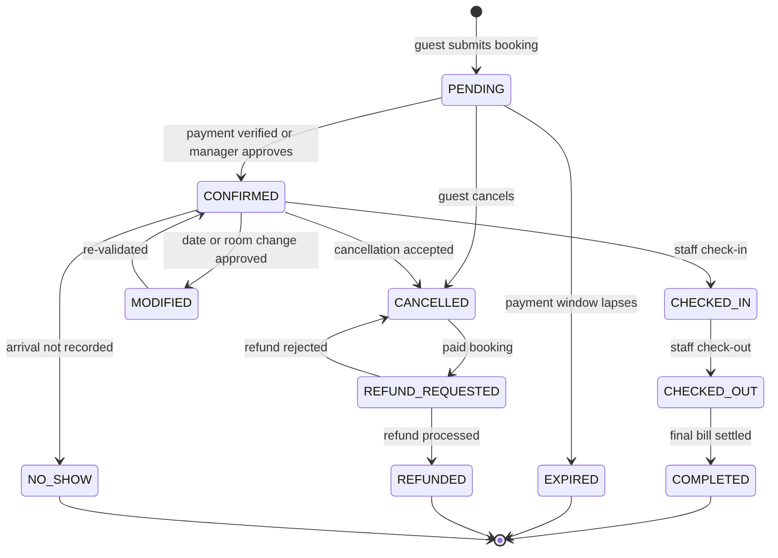
Figure 1: Booking status lifecycle
Table 2: Business rules
Rule | Description
Price calculation | nights × (category base price, or seasonal rule price by night) + taxes; computed on the server
Hold | A PENDING booking holds the room until expiresAt (duration To Be Confirmed)
Cancellation policy | Refund eligibility depends on hotel policy (cancellationWindowHours, cancellationFeePercent) – values To Be Confirmed
Modification | Guest requests; manager approves; availability and price re-validated
Check-in | Allowed only for CONFIRMED bookings on/after check-in date (rule TBC)
Completion | COMPLETED after check-out and bill settlement; enables review

References
- Express Routing – https://expressjs.com/en/guide/routing.html
- REST API Design – Microsoft Guidance – https://learn.microsoft.com/en-us/azure/architecture/best-practices/api-design
- Stripe Webhooks – https://docs.stripe.com/webhooks
- Razorpay Payment Verification – https://razorpay.com/docs/payments/server-integration/nodejs/payment-gateway/build-integration/

